**Transformer Design**

Since we are not limited by the available cores in the laboratory, we have revisited our transformer design that we completed for simulation report. In order to find a proper core, we first calculated required area product for our design according to equation (1).

$$W_{a}A_{c}=\frac{P_{o}*D_{cma}}{{K*B}_{max}*f_{s}} (1)$$

|  |  |  |
| --- | --- | --- |
| Parameter | Description | Value |
| $$P_{o}$$ | output power | 48W |
| $$D_{cma}$$ | current density | 500 cir. mils/amp = 4A/mm2 |
|  | topology constant | 0.0005 |
| $$f_{s}$$ | switch frequency | 40 kHz |
| $$B_{max}$$ | max flux density | 1750 Gauss |

According to equation (1) and above parameters, area product is calculated as 0.686. Then, we have selected 0P43009EC core whose area product is 0.74.

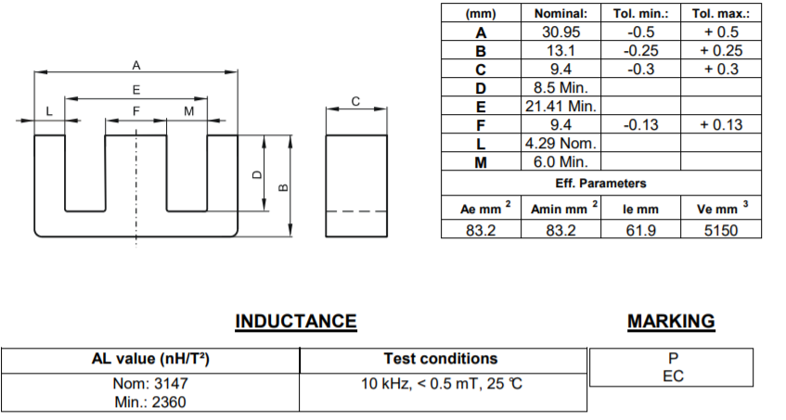

Figure 1. Properties of 0P43009EC

We used formula (2) to find minimum number of primary winding not to saturate the core. By choosing $N_{1}=N_{3(reset)}$, we limited the maximum duty ratio to 50% in order to reset the reset the transformer.

$N_{1}>\frac{V_{i,max}*D_{max}}{f_{s}*B_{sat}*A_{e}} (2)$

In equation (3), $V_{i,max}=48V$, $D_{max}=0.5$, $f_{s}=40kHz$ and $B_{sat}=0.3T$, $A_{e}=83.2 {mm}^{2}$, for our core selection. For given parameters $N_{1}>24.1$, and we decided that $N_{1}=25$. As we mentioned in the previous parts, $N_{1}=N_{3(reset)}$.

For a forward converter, input-output relationship is given by equation (3).

$$\frac{V_{o}}{V_{i}}=\frac{N_{2}}{N_{1}}*D (3)$$

Vi=24V is the limiting input voltage since increases in Vi can be overcome by lowering duty ratio. We need Vo=10V at the output of the converter. However, since equation (3) is derived for ideal components, when we simulate the circuit considering non-idealities such as winding resistances and leakage inductance, we need to use higher number of turns for secondary winding. According to simulations setting $N_{2}$ =40 turns gives good results. Hence, turns numbers of the windings are as follows, $N_{1}=N_{3(reset)}$ =25 turns, $N_{2}$ =40 turns.

AWG-22 cable, 0.327 mm2 cross section, is applicable for 40 kHz switching frequency. Primary winding RMS current value is 3.6ARMS. To have 4 A/mm2 current density, 0.9 mm2 conductor area is required. Hence, we need to parallel 3 wires and obtain 0.98 mm2 conductor area for primary winding. Secondary RMS current is 2.22 ARMS and 2 parallel AWG-22 cable results in 3.4 A/mm2 current density. Since reset winding current is very small, we can use much thinner wire. However, to decrease copper loss, we use same AWG-22 cable for reset winding. Then, we have calculated the fill-factor of the transformer by equation (4) to check if the conductors fit in the window area of the selected core.

$$k=\frac{A_{conductor}}{A_{window}}=\frac{25*\left(3*0.327+0.327\right)+40*2*0.327}{102}=0.58 (4)$$

As shown above, filling factor is reasonable and selecting AWG-22 cable for reset winding is not problem.

To find magnetizing inductance of the transformer, we used inductance factor (AL) given in the datasheet of the core. From equation (5), calculated that Lm=2mH.

$$L_{m}=A_{L}*N^{2} (5)$$

Mean length of the windings is calculated according to equation (6) and winding resistances are calculated form equation (7). Resistance of 1-meter AWG-22 cable is 53mΩ.

$MLT=\left(\frac{E+F}{2}\right)*π=48.4 mm (6)$

$R=\frac{\left(MLT*Turns\right)}{Number of parallels}*53 mΩ (7)$

Calculated resistances for primary, secondary and reset windings are as follows: R1= 21.38 mΩ, R2= 51.3 mΩ, R3= 64.13 mΩ. These resistances are used in simulations of the transformer.

Core manufacturer, Magnetics, provides equation (8) to calculate core loss of the transformer. Parameters in the original equation is replaced by the given values of the P type material.

$$P_{CL}=\frac{3.2*f^{1.46}*B^{2.75}*(2.45-0.031*T+0.000165*T^{2})}{1000}*V_{e}=845 mW (8)$$